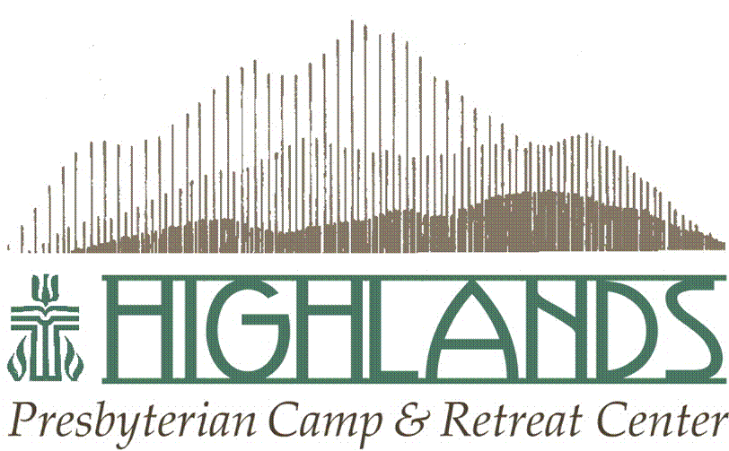
Day Camp Application For Returning Partners
Summer 2021

Church Name: ___________________________________________________________________________

Church Address: _________________________________________________________________________
(Street) (City) (State) (Zip)

Pastor Name: ______________________ Church Phone Number: __________________________________

Name of Person Completing Application: ______________________________________________________

Contact Information for Person Completing Application:

Address: ________________________________________________________________________________
(Street Address) (City) (State) (Zip)

Home Phone: ______________ Cell Phone: _____________ Email: _______________________________

Please answer the following questions for us to get a sense of how we can best serve your congregation:

- For 2021, Highlands is seeking to hire one Day Camp Director to lead our team. Because our insurance requires an individual be 21 years of age or older to drive a Highlands’ vehicle there is the possibility that we might find a qualified person for the position who is unable to drive their team to the church each day from their host home(s). Would your church be able to provide transportation for the Highlands staff from their host home to the church and back each day? (Highlands staff would be transported to your church on Sunday afternoon and picked up on Friday at the conclusion of the day camp program).

- How does your congregation anticipate utilizing Highlands staff for half-days of meaningful service projects for four days?

- Will your congregation partner with other local congregations to provide Day Camp?

Name of Congregation_______________________________________________________

- Please rate the following weeks for preference. (1 = most desired, 2 = second most desired, etc.)

  - _____ June 20-25, 2021

  - _____ June 27-July 2, 2021

  - _____ July 4 (or 5) – July 9, 2021

  - _____ July 11-16, 2021

  - _____ July 18-23, 2021

  - _____ July 25-30, 2021

  - _____ Aug 1-6, 2021

Please send this completed application as soon as possible to:

Highlands Presbyterian Camp and Retreat Center
PO Box 66
Allenspark, CO 80510
or maria@highlandscamp.org

